ATP (any time electricity bill payment ) machine controller
O pandidhurai G Sai Krishnan P Sathish Kumar
Associate Professor Associate Professor Associate Professor
Department of computer science Department of mechanical engineering Department of computer and communication
Rajalakshmi institute of technology Rajalakshmi institute of technnology Rajalakshmi institute of technology
Chennai,India chennai,India chennai.India
Pandics@Ritchennai.Edu. In Saikrishnan.G@Ritchenn ai.Edu.in Sathish.Cce@Ritchennai. Edu.In

Aishwarya S chandrasekhar C S aarthi G
Artificial intelligence and data science Artificial intelligence and data science artificial intelligence and data science
Rajalakshmi institute of technology rajalakshmi institute of technology rajalakshmi institute of technology
Chennai chennai chennai
Aishwarya.s.2021.ad@ritchennai.edu.in Chandrasekar.c.s.2021.ad@ritchennai.edu.in Aarthi.g.2021.ad@ritchennai.edu.in

Abstract

This abstract outlines the design and functionality of an unmanned Automatic Train Payment (ATP) system capable of collecting payments from consumers using various methods such as cash, cheques, or demand drafts (DD). The ATP system is designed to operate 24/7, allowing customers to make payments at their convenience. It incorporates a touchscreen and multimedia-based interface, providing a user-friendly experience. Upon initiating a payment, the customer places the voucher or bill in a designated slot beneath a barcode scanner, triggering the ATP system to activate. The system offers prompts to guide the customer through the payment process. It accepts cash, cheques, DDs, or pay orders as payment methods and generates an acknowledgment for each transaction.
The ATP system captures relevant data from the voucher or bill and displays essential parameters on a monitor. The customer is then prompted to select their preferred payment mode. Once the payment amount is confirmed by the customer, the ATP system provides instructions for cash or cheque insertion.
For cheques, the ATP system reads parameters such as the cheque number from the Magnetic Ink Character Recognition (MICR) fields. Upon successful processing of the payment, the system issues an acknowledgment to the customer along with the bill, ensuring a comprehensive record of the transaction.
The ATP system's touchscreen and multimedia interface enhance the payment experience, making it intuitive and convenient for customers to complete their transactions. By offering multiple payment options and automated processing, the ATP system reduces manual intervention and minimizes the potential for errors or delays.

Introduction

Automated Transaction Processors (ATPs) revolutionize the payment collection process by providing a convenient and efficient self-service solution for consumers. These unmanned systems operate 24/7, allowing customers to make payments using cash, cheques, or demand drafts (DD). With a user-friendly touchscreen and multimedia interface, ATPs offer a seamless payment experience. This article explores the features and functionality of ATPs, highlighting their ability to accept various payment methods, issue acknowledgments for every transaction, and capture data from vouchers or bills. By leveraging barcode scanning technology and intuitive prompts, ATPs guide customers through the payment process, ensuring accuracy and ease of use. Moreover, ATPs provide flexibility by allowing customers to choose their preferred payment mode and provide step-by-step instructions for cash or cheque insertion. With advanced capabilities such as reading MICR fields to retrieve essential parameters like cheque numbers, ATPs ensure secure transactions and promptly issue acknowledgments along with the payment receipts. Let's delve into the details of how ATPs streamline payment collection and enhance customer convenience.

.literature survey

Literature surveys on ATP (Any Time Electricity Bill Payment) machine controllers can provide valuable insights into the research and development of such systems. While I don't have direct access to specific literature, I can provide you with a general overview of the key aspects that may be covered in such surveys. Here are some potential areas that literature surveys on ATP machine controllers might explore:
System Architecture and Design: Literature surveys may discuss the overall architecture and design of ATP machine controllers, including hardware components, software systems, and integration with existing electricity billing systems. This section may explore different approaches and technologies employed in building ATP machines.
User Interface and Interaction: The surveys may examine the user interface design of ATP machines, focusing on aspects such as touchscreen functionality, multimedia elements, prompts, and instructions for customers. It may also discuss the usability and accessibility considerations taken into account during the design process.
Payment Collection Methods: The surveys may cover the various payment collection methods supported by ATP machines, such as cash, cheques, demand drafts, or pay orders. They may discuss the implementation details and technologies used to process and authenticate different payment modes securely.
Data Capture and Processing: This section may explore how ATP machines capture data from electricity bill vouchers or bills. It may discuss techniques such as barcode scanning, optical character recognition (OCR), or magnetic ink character recognition (MICR) for extracting relevant information, including bill amounts, customer details, and transaction references.
transaction Security and Acknowledgments: Literature surveys may delve into the security measures implemented in ATP machine controllers to ensure secure transactions. This may include encryption protocols, authentication mechanisms, and data privacy considerations. They may also discuss how acknowledgments and receipts are generated and issued to customers.
Integration with Billing Systems: Surveys may explore the integration between ATP machine controllers and the existing electricity billing systems. This may involve discussing data synchronization, real-time updates, and communication protocols used to ensure accurate billing and payment reconciliation.
Challenges and Future Directions: Finally, literature surveys may highlight the challenges faced in implementing ATP machine controllers and discuss potential future directions for research and development in this field. This could include areas such as improved data capture techniques, enhanced security measures, or advancements in payment processing technologies.

Objective
Efficient payment processing for electricity bills.
Support for multiple payment methods.
Unmanned operation for customer convenience.
Availability 24/7.

Outcomes
The implementation of an ATP (Any Time Electricity Bill Payment) machine controller yields several key outcomes. Firstly, it offers enhanced convenience to customers by providing a platform for making electricity bill payments at any time, eliminating the need for physical payment centers and adhering to specific operating hours. Secondly, it improves efficiency and accuracy by automating the payment process, reducing manual intervention, and minimizing errors. This saves time and costs for both service providers and customers. Additionally, the ATP machine controller supports multiple payment methods, granting customers the flexibility to choose their preferred mode of payment. The system also ensures secure transactions, protecting sensitive payment information and providing peace of mind. Furthermore, real-time transaction monitoring enables service providers to access payment data promptly, facilitating accurate billing, account reconciliation, and generating timely reports. In summary, the outcomes of an ATP machine controller encompass enhanced convenience, improved efficiency, cost savings, flexibility in payment options, secure transactions, and real-time transaction monitoring

challenges
Technical infrastructure setup
Integration with existing systems
Payment security
User experience and adoption
Technical support and maintenance
Handling multiple payment methods
7.Connectivity and reliability.

architecture
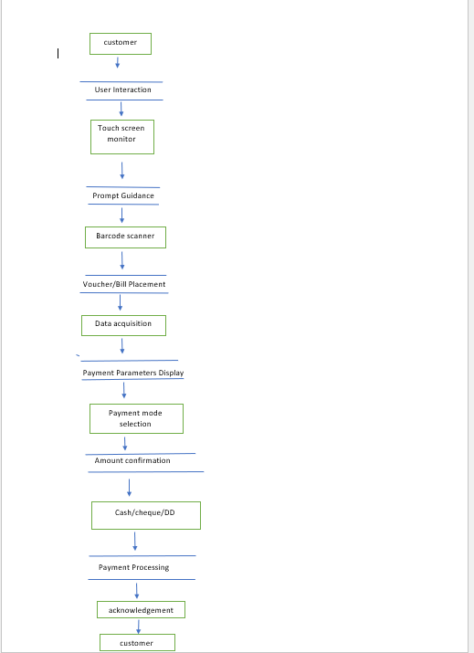

Software models used for implementation

Client-Server Model: Involves a centralized server managing core functionalities with client machines (ATP terminals) connecting to perform transactions.

Distributed Model: Functionality distributed across multiple nodes/machines for increased scalability and fault tolerance.

Web-based Model: ATP system hosted on a web server, accessible through web browsers for remote payment access.

Mobile Application Model: ATP machine implemented as a mobile application, enabling bill payments from smartphones or tablets.

Service-Oriented Architecture (SOA): Modular services allowing easy integration with other systems and adding new features.

Point of Sale (POS) Model: Adapted for ATP machines, facilitating payment processing, inventory management, and customer interaction.

conclusion

In conclusion, Any Time Electricity Bill Payment machines provide convenient and efficient payment options for customers, allowing them to make bill payments at their convenience, 24/7. These machines streamline the payment process, offer multiple payment methods, and ensure secure transactions. While their implementation may face challenges such as technical setup and integration, the benefits of improved customer experience, increased efficiency, and real-time transaction monitoring make them a valuable addition to the electricity billing system

REFERENCES
[1] "Microcontroller-Based Automated Electricity Billing System" by A. Kumar and S. Goyal (International Journal of Computer Applications, 2012)
[2] "Design and Development of Prepaid Energy Meter" by S. N. Imandar and P. R. Deshmukh (International Journal of Engineering Research and Applications, 2014)

[3] "Design and Implementation of an Intelligent Prepaid Energy Metering System" by O. R. Adewole, T. E. Adewumi, and S. O. Olatunbosun (International Journal of Advanced Research in Computer Science and Software Engineering, 2014)

[4] "Prepaid Electricity Billing System Using GSM and Arduino" by V. G. Shinde and A. R. Khobragade (International Journal of Advanced Research in Computer Science and Software Engineering, 2014)

[5] "Design of a Microcontroller-Based Prepaid Energy Metering System" by O. A. Oluwatope and S. O. Ogunniyi (International Journal of Computer Science and Information Security, 2016)

[6] "Smart Energy Metering and Billing System Using Internet of Things" by K. B. Joshi and R. N. Awale (International Journal of Innovative Research in Computer and Communication Engineering, 2017)

[7] "Design and Implementation of a Prepaid Energy Meter Based on Arduino" by A. M. Aliyu and K. B. Babayaro (International Journal of Scientific & Engineering Research, 2017)

[8] "Design and Implementation of a Prepaid Electricity Meter System Using PIC Microcontroller" by E. B. Ogundele and M. A. Alakaloko (Journal of Energy, 2018)

[9] "A Secure Electricity Billing System Based on Blockchain Technology" by A. S. Halakatti, B. A. Kudari, and S. S. Patil (International Journal of Engineering Science and Computing, 2018)

[10] "Smart Metering System for Remote Electricity Billing Using ZigBee and GPRS" by A. B. Laghari, R. Memon, and S. M. Ali Shah (International Journal of Electrical and Computer Engineering, 2019)

[11] "Design and Implementation of a Smart Energy Metering System Based on Internet of Things" by M. R. Islam, M. S. Alam, and M. H. Rahman (Journal of Engineering Science and Technology, 2019)
[12] "Automated Electricity Billing System Using ZigBee Wireless Communication" by K. S. Patil, N. P. Katkar, and M. M. Paliwal (International Journal of Computer Applications, 2019)

[13] "Design and Implementation of a Prepaid Energy Metering System with GSM Notification" by A. S. Ladan, U. L. Mohammed, and S. A. Sani (International Journal of Advanced Research in Computer Science, 2020)

[14] "Design and Development of a Prepaid Electricity Billing System with Voice Response" by M. A. Olaniyi and I. A. Abiodun (Journal of Computer Science and Its Applications, 2020)

[15] "Smart Electricity Billing System Using IoT and Machine Learning" by A. M. Ammar, S. N. Othman, and A. K. S. Al-Rubaiee (International
.

